**The Nagging Co-Pilot (aka Ivy).**

Gone are the days, when you could fly without transponder, enlighten the stratosphere with your landing lights or switch off the beacon lights for a shortcut to the runway .

Now that your airline has assigned your new co-pilot no mistake will go unnoticed. So make sure that you fly properly!

**Introduction**

When I first implemented this plugin, I just wanted to break the silence in the virtual cockpit, implementing a co-pilot voice that would make stupid comments on all your errors. Therefore, I took the most annoying voice I found on Amazon Polly, which is a very easy to use and scriptable text to speech processor. Her name was Ivy and the plugin simply got that name.

However, as time passed by, I grew wary of the voice, so I implemented many more voices and went from funny comments to semi-professional call-outs (the old version is still there – just select the Ivy Funny voice). Over time, the list of errors to be detected grew and I wanted more tools for my flight analysis. I also added more and more call-outs to make the atmosphere in the cockpit more alive.

For the Cowansim Bell 206 B3 as well as the Long Ranger, I also followed the pilots handbook, made sure stuff breaks if you aren’t careful and even made sure that switches are never in the same position each time you start a flight.

**Installation:**

You need the following to run Ivy:

* Copy the contents of the zip file (i.e., the Ivy folder) to X-Plane 12\Resources\plugins

So far, I support only Windows.

**Implemented Failure Detections:**

1. Bump on the ground
2. Tire blown
3. Hard braking
4. Transponder not active when airborne
5. Landing lights not on when close to the ground in the night
6. Landing lights not off on high altitude
7. Beacon lights not on when taxiing
8. Nav lights not on when airborne
9. Strobes not on when airborne
10. Battery low
11. Engine fire
12. Engine flameout
13. Engine ground failure
14. Engine airborne failure
15. Engine hot start
16. Engine bird strike
17. Battery not on
18. Aircraft overspeed
19. Flaps overspeed
20. Gear overspeed
21. Stall
22. Cabin pressure raising too fast
23. Cabin pressure raising extremely rapidly
24. Bank angle pre-warning
25. Bank angle too high
26. Bank angle extremely high
27. Pitch down pre-warning
28. Pitch too low
29. Vertical G Force high
30. Vertical G Force very high
31. Vertical G Force very, very high
32. Vertical G Force too low
33. Vertical G Force negative
34. Barometric pressure not set accordingly while close to ground or taxiing (within tolerance)
35. Barometric pressure not set to standard above transition altitude
36. Ice airframe low
37. Ice airframe high
38. Ice pitot low
39. Ice pitot high
40. Ice propeller low
41. Ice propeller high
42. Ice cockpit window low
43. Ice cockpit window high
44. Cabin pressure low
45. Cabin pressure too low to breath
46. Birdstrike

Most variables needed to configure the tolerances of failure detection are editable in the **Ivy.ini** file.

**Landing evaluation:**

After each landing, your co-pilot will give you a ranting for your landing and tell you the sink rate upon touch down as well as the g-forces. Most people only think about sink rate upon landing, however, your passengers will not fly with you again, if the g-forces upon landing are too high. No matter what your vertical speed was.

The rating is the following:

*Rating A:*

Sink rate < 100 ft/min

Vertical forces < 1.5g

*Rating B:*

Sink rate < 250 ft/min

Vertical forces < 2g

*Rating C:*

Sink rate < 400 ft/min

Vertical forces < 3g

*Rating D:*

Sink rate < 500 ft/min

Vertical forces < 4g

*Rating F:*

Everything else that did not trigger the X-Plane crash detection

A proper landing requires you to **touch down and stop the aircraft** for more than **5 seconds**. An aircraft is considered stopped if the ground speed is below taxi speed (default: 5 kt). The rating includes **all bounces** within a 10 seconds window before your final touchdown.

Furthermore there is a rating of your flight, depending on the errors you made:

0 Errors : Excellent

<5 Errors : Good (nice)

<10 Errors : Bad (not nice)

>=10 Errors : Horrible

Details of your highest sink rate and vertical g-forces are spoken upon landing (including all bounces in the evaluation)

As aircrafts are sometimes placed above the ground on loading and it is pretty annoying to get a landing evaluation in such an event, you need to be airborne at least 100ft while having a climb rate of >100 ft/min. This means that just hovering a bit and putting a helicopter back to the ground, also does not trigger a landing evaluation.

Every landing is stored in your IvyLogbook. The landing is **only stored**, if you wait for the landing evaluation. If you exit X-Plane before, it will not be saved.

**Implemented callouts for all aircraft:**

1. Gear down callout
2. Gear up callout
3. 60/80/100 knots callouts (setting via menu)
4. Positive rate of climb (default: 100ft/min)
5. Approaching Minimums (default: DH+100, DH must not be zero)
6. Fasten Seatbelts
7. Take Off Announcement on Non-Smoking Toogle or Commmand
8. Landing Announcement on Non-Smoking Toogle or Commmand
9. Speed Brakes / Spoilers
10. Localizer / Glide Slope Alive
11. Airspeed Alive
12. Power Set (or rather power settled somewhere in the upper region)

If enabled:

1. Starting Engine
2. Fuel on
3. Light Up
4. N2
5. Engine Stabilized

Remember that Ivy is a Union member and will only perform one take off and one landing announcement per flight. However, she might consider doing it on multi-leg flights. Unfortunately, some airplanes do not put seat belts or non smoking sign switches on the corresponding X-Plane Datarefs.

**Implemented callouts for specific aircrafts:**

* V-Speeds:
  + V1
  + VR
  + V2
  + V2 not achieved within 5 seconds after take off
* Flaps settings
* Slats settings

I supply multiple aircraft configuration files, but I can only implement and test them for aircraft I own. Auto V-Speeds are currently available Rotate MD-80. Static V-Speeds can be set via the control window.

Flaps/Slats are implemented for the following aircraft:

* All Lamiar Aircraft that come with X-Plane 12
* Rotate MD-80
* Felis 747
* Toliss A319
* Jetstream 32
* Phenom 300

You can open the data for slats and flaps positions via menu or command and create your own configuration file if you like. A small tutorial can be found in the Appendix.

**Control Window**

All the detailed functions of the plugin can be accessed via the control window, which can be enabled in the menu. The MyFlight tab enables the most important functionality, such as the output volume (via the XP12 co-pilot channel), speed callouts, v-speeds, NOE enable (see below) or the MTBF. The last one is only visible if you are in a special mode, where Ivy does nasty stuff such as kicking out your circuit breakers.

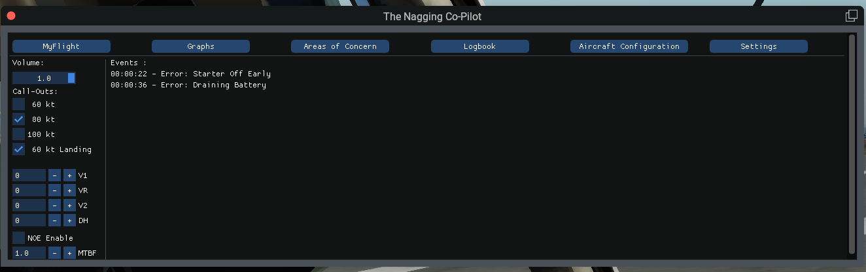

The control window also allows for a detailed flight analysis when clicking the Graphs tab. Analyze frequent mistakes in Areas of Concern or look at your flight history via the Logbook tab.

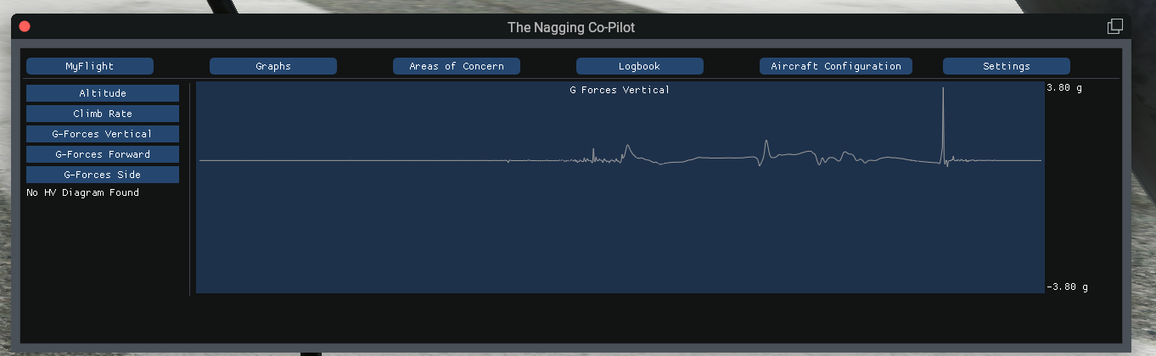

**NOE Enable**

For the military guys out there, you are also able to enable an altitude that you are not allowed to exceed, so that you can train flying below the radar. Therfore, you need to define a maximum altitude in the Aircraft Configuration tab:

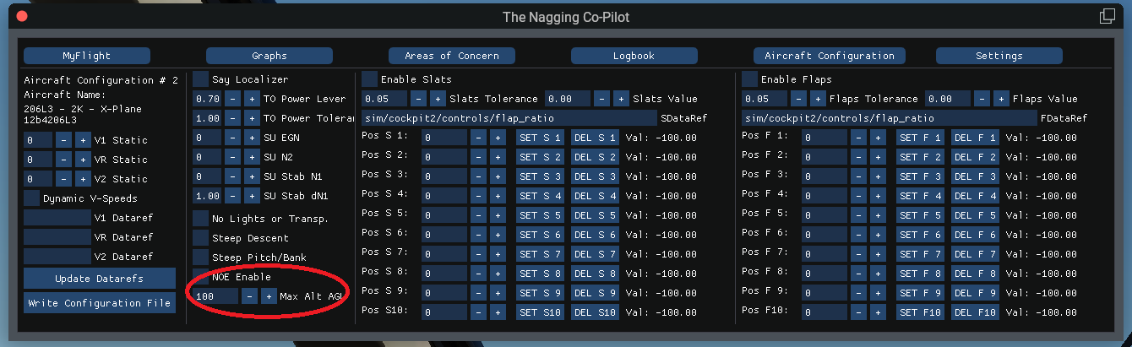

**Commands**

The following commands can be bound to your keyboard:

* *Ivy/cabin_announcement*: Ivy will make a Take-Off or Landing announcement.
* *Ivy/say_baro:* Say the current barometric pressure
* *Ivy/say_wind*: Say wind direction and speed
* *Ivy/show_output*: Show the flaps/slats position for creating *IvyAircraft_X.ini*
* *Ivy/reset_ivy*:Resets Ivy. Recommended for multi leg flights.

**V-Speed Callouts**

If your aircraft does not have datarefs for the v-speeds configured, you can access the v-speed settings via the Control Window: Menu/Plugins/Nagging Co-Pilot/Toogle Control Window

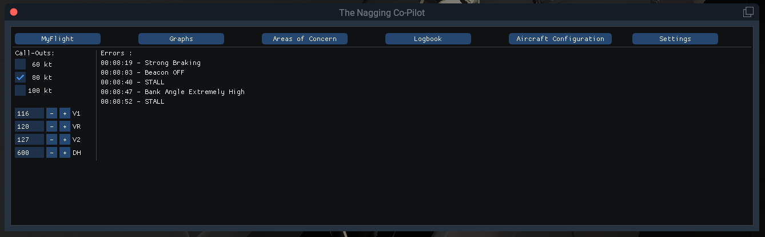

Here, you can set the individual v-speeds for your session. Zero values disable the affected callout. You can also enable/disable the callouts for 60/80/100 knots or set your decision height in case your aircraft does not support this. The 60/80/100 knots callouts are saved when you close X-Plane, as these callouts are not necessarily aircraft specific.

The definition of dataref based v-speeds or static v-speeds for individual aircraft is described in the Appendix.

**Logbook**

Ivy remembers everything! She keeps precise tracking of all your mistakes and landings, noting every detail in your logbook. At least, most of it. You can open your loogbook in the plugins menu. You can also find the IvyLogbook.txt in your PythonScripts folder. In case you want to cancel a flight, you can simply edit the text file.

Arrival and departure airports are simply the next Airport Refs from your take-off/landing. There are certain runways in x-plane close to another airport, which might cause wrong airport names. This is a well known limitation of X-Plane and there is nothing I can do about it.

The landing is **only stored**, if you wait **20 seconds** after touchdown for the landing evaluation. If you exit X-Plane before, it will **not** be saved.

**Helicopters**

For those who know my other plugins, it’s rather obvious that there must be some helicopter specific stuff.

***Height Velocity Diagram***

The Height Velocity Diagram, also called Deadman’s Curve describes the safe area where a helicopter can be safely landed in case of an engine failure. Failure to comply might end up in a deadly accident, especially during take off in a helicopter powered with rather unreliable piston engines.

To enable the height velocity, open the zip files that are in the root folder of the plugin and copy the hv_diagram.ini to the aircraft folder of the helicopter it’s intended for. ATM I support the Bell 206B3, Bell 206L3 and S300 Cbi.

You can also write your own diagrams. Just open one of the predefined files and edit them. hv_point_#_v=XX defines the speed in kt and hv_point_#_h=XX defines the height in foot. The plugin expects two curces, as this is the most common case in real HV diagrams.

Within the control window, under the Graps section, you will see a trace of your flight in height and velocity.

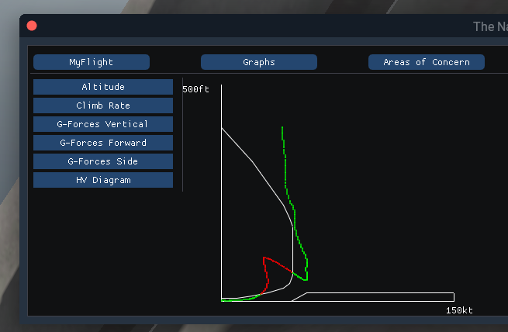

***Cowansim Bell 206 B3 / L3***

I made a dedicated training version for the Bell 206 B3, as requested by a flight sim colleague who went into RL training. I tried to follow the pilot’s handbook as close as possible.

* Battery draining
  + Generator off and:
    - Landing Lights on
    - Nav Lights on
    - Anti Ice on (Pitot or Engine)
    - Heater on
* Engine start preconditions not met
  + Landing lights on
  + Anti ice on (Pitot or Engine)
  + Hydraulics Off
  + Breakers not all in
  + Generator on
  + Caution Lights not tested
  + TOT Temperature test not performed
  + Controls not neutral
  + Beacon Lights off
  + Throttle not off
* Starter off early
  + N1 < 55%
* Starter off late
  + N1 > 65%
* Cyclic not centered
  + Below 90% rotor rpm
* Collective high
* Pitot heating hot
  + > 4.4°C Outside Temperature
* Anti ice hot
  + > 4.4°C Outside Temperature
* Engine idle time not considered
  + Throttle must be idle for 3 minutes before shutting down
* VRS danger
  + < 30kt and vertical speed < -300 ft/min
* Circuit breakers not in valid position
  + Either at engine start or while engine running
* High engine wear
  + Below 88% rotor rpm, torque must be below 33%
* Above maximum altitude
  + Weight < 1360 kg: 20000ft absolute
  + Weight > 1360 kg: 13500ft density altitude
  + Weight < 1882kg: 20000ft absolute
  + Weight > 1882 kg: 10000ft density altitude
* Overspeed:
  + Without doors: 69kt
  + If torque >85%: 80kt
  + IAS > 130kt – (density altitude – 3) * 3.5 /1000
  + Without doors: 90kt
  + If torque >85%: 84kt
* Wind azimuth area (only 206B3):
  + Above >kt wind speed, the relative angle of attack must not come from >50° or < 210°
* Generator early on
  + N1 < 60%
* Ivy will put your engines on fire or break your rotor if:
  + Engine Overspeed:
    - N1 > 106%
    - N1 > 105% after 5 seconds
    - N1 > 104%
    - N1 > 101% after 4 seconds
  + Overtorque:
    - >= 110% after 0.1 seconds
    - >= 100% after 5 seconds
    - >= 85% after 5 minutes
    - Would be different for L3, but in-sim instruments markings are the same
  + ITT in Air:
    - >= 738°C after 5 minutes
    - >= 810°C after 6 seconds
    - >= 843°C after 0.1 seconds
    - >= 716°C after 5 minutes
    - >= 871°C after 6 seconds
  + ITT on Ground:
    - >= 738°C after 5 minutes
    - >= 810°C after 10 seconds
    - >= 716°C after 5 minutes
    - >= 871°C after 10 seconds
  + Transmission Oil Pressure in Air:
    - <= 30 PSI after 10 minutes
    - >= 50 PSI after 5 minutes
    - >= 70 PSI after 0.1 seconds
    - <= 30 PSI after 10 minutes
    - >= 70 PSI after 0.1 seconds
  + Oil Pressure on Ground:
    - Same, but no lower limit
  + Oil Temperature in Air
    - >= 107°C after 0 seconds
  + Oil Temperature on Ground
    - Only upper limit applies
  + Only Warning: Rotor RPM (only in air and only if engine is running):
    - < =95% after 0 seconds
    - < = 97% after 5 seconds
    - >= 105% after 1 second
  + Only Warning: RotorRPM in air with engine failure
    - <= 90% after 1 second
    - >= 107% after 1 second

As if this wasn’t bad enough, Ivy likes to flip a switch/circuit breaker during startup and sometimes even during flight (MTBF is one hour).

**What else is there to say?**

Remember that fun is subjective. If you don't like certain call outs, you can simply remove the individual audio file, if the end on "_#.wav". Ivy is not resentful and during all my tests, she never complained about missing files. You can also create your own sound files as described below, in case you prefer something different. However, if you don't like the plug-in at all, go write your own.

All speech was generated using the Amazon Polly Text-to-Speech synthesis engine. You may generate your own sound files, if you want more proper call outs. You just need an AWS account, which is currently free of charge or any other speech synthesis software. However, just to be on the safe side: I hereby deny the use of any speech that contains sexism, racism or fascism (there are always some idiots out there).   
  
Amazon offers a variety of voices and it is definitely on my ToDo list to generate different voice packs. Ivy is just the most funny voice that I decided to start with.

This software is published under the GNU General Public License v3. Remember that this gives you no warranty for functionality and by using this software, you yourself take the full responsibility for any fatalities caused by any bugs.

Another disclaimer that should be obvious: This software was **not** written by a professional pilot. It does **not** follow any real life procedures and is **not** safe for flight training.

**References**

The passenger screaming was taken from freesound.org under the attribution license:  
https://freesound.org/people/InspectorJ/sounds/421852/

The other sounds were also taken from freesound.org, where all chosen sounds were using the creative commons 0 license.

**Appendix**

**How to create an IvyAircraft.ini:**

The creation of an IvyAircraft.ini was moved into the control window:  
  
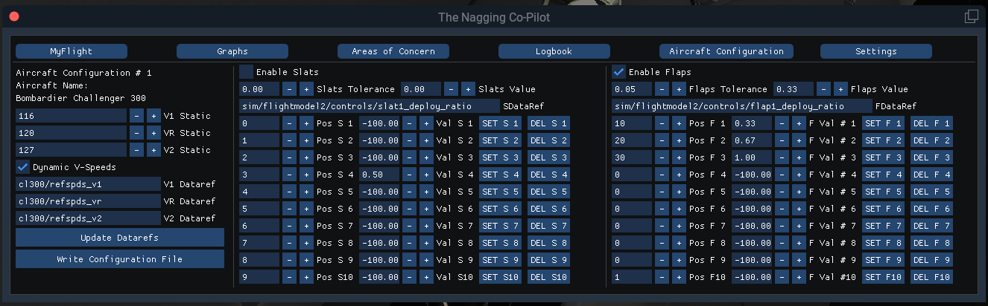

To create a flap setting, first click Enable Flaps then move your flaps to all possible position and enter the position value on the left hand side. Then simply press "Set F #", your setting will be stored and the value field will be updated. Value fields are read-only, the +/- fields are just not removable by ImGui. The first flap position always has to be the retracted position with value 0.

Do not forget to write your configuration file after updating.

There is now automatic type detection for v-speed datarefs. Flaps/Slats datarefs are floats, so is their value. Positions must be integer (Ivy say numbers does not support floats). V-Speed datarefs must be integer. There is a workaround in place for the Rotate MD-80, which uses an array of floats for the v-speeds, but therefore you need to enable the array position within the Ivy.ini. If your flaps dataref is wrong, no data will appear in the output.